AUTISM ASSESSMENT SCHOLARSHIP APPLICATION 2025

Autism Diagnostic Assessment Scholarships are available for children to access assessment services provided by Kids Are Kids!

The closing date for applications is Thursday 2nd October 2025 at 4pm.
These scholarships are available thanks to a generous donation by Azure Capital Foundation and a Perpetual Impact Grant funded generously by The Carlo and Roslyn Salteri Foundation.
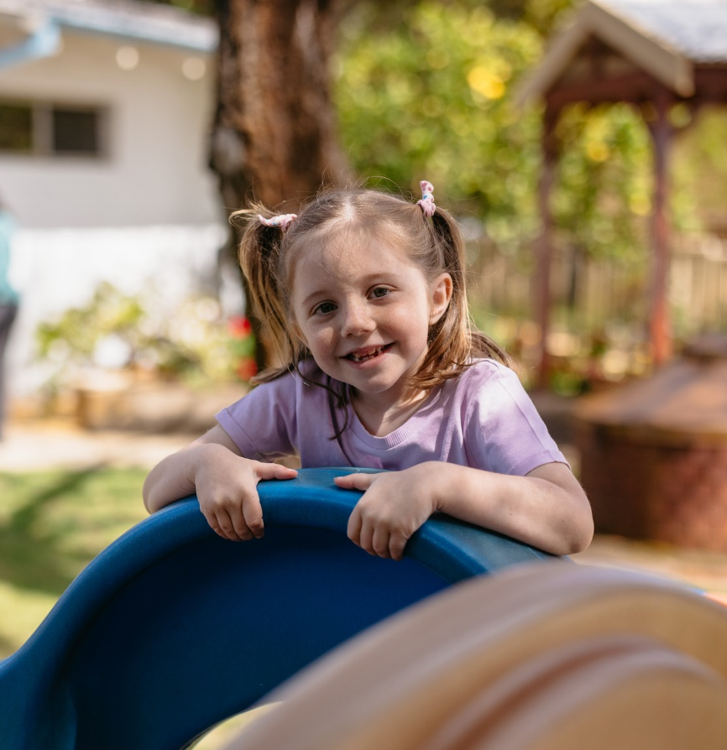

Applications for the 2025 Autism Assessment Scholarships are now open to any family whose child meets the following criteria:
- Aged between 0 - 18 years
- Is showing traits or characteristics of neurodiversity (Autism).
- Lives in Western Australia.
- Have not been previously assessed for autism
Priority will be given to applicants who are unable to afford the cost of an assessment. Moreover, priority will be given to applicants who, without an assessment or while experiencing a long wait time for assessment, will continue to have significant difficulty or deterioration in their functioning, participation and engagement at school, home and in the community.
Application and Attachments:
Please provide answers to the following questions and attach any additional information that you believe may support your application.
All information received will be maintained in confidence. Families may choose to consent to an advocate complete this application on their behalf.
General Assessment Details
An assessment can take up to 5 hours of direct assessment. This will involve both direct assessment of your child and observations of your child in a natural setting, as well as a parent and teacher clinical interview and completion of questionnaires. Therefore, parents must have the capacity to be involved in the assessment process.
Barriers to completing an assessment would include parents not having capacity to participate in the clinical interview or completion of questionnaires.
Closing Date:
The closing date for applications is 4pm on 2nd October 2025.
Send Application to: Lisa Hoffman, Executive Officer
Mail: Kids Are Kids! PO Box 1096, Booragoon WA 6954
Hand delivery: 26 Parry Avenue, Bateman WA 6150 or 16 Clarence Road, Armadale 6112
Email: info@kidsarekids.org.au
Notification:
Families will be notified of the application outcome by phone or email by December 2025.
Kids Are Kids! Autism Assessment Scholarship Application Form
Child’s name: Click or tap here to enter text.
DOB: Click or tap here to enter text.
School: Click or tap here to enter text.
Year Level: Click or tap here to enter text.
Contact person (i.e., Parent/Carer): Click or tap here to enter text.
Street Address: Click or tap here to enter text.
Suburb: Click or tap here to enter text.
Postcode: Click or tap here to enter text.
Email: Click or tap here to enter text.
Mobile: Click or tap here to enter text.
☐ A supporting letter from my GP/Paediatrician is enclosed (optional)
Is the child an Australian citizen or permanent resident? (Please tick one)
Yes ☐ No ☐
If no, please provide details: Click or tap here to enter text.

Is the application being completed by a third party on behalf of the family? (Please tick one)
Yes ☐ No ☐
If yes, please provide your contact details : Click or tap here to enter text.
Please answer all questions on the application form and provide as much information as possible in each section. Additional reports or supporting documents may be attached to this application.

1. Profile of your child's situation – please describe the type of concerns/difficulties your child has using the categories below. If relevant please include schooling, family situation, the effect and impact of the difficulty on the family and the child's quality of life.
Language and communication
Click or tap here to enter text.

Self-care, self-regulation and life skills
Click or tap here to enter text.

Social/emotional development
Click or tap here to enter text.

Sensory Development
Click or tap here to enter text.

Gross/fine motor skills
Click or tap here to enter text.

Cognitive and learning skills
Click or tap here to enter text.

Attention, concentration and memory
Click or tap here to enter text.
Impact on the family
Click or tap here to enter text.

2. School and Social History
How is your child performing at school academically?
Click or tap here to enter text.

Has your child received any educational support or accommodations?
Yes ☐ No ☐
If yes, please describe Click or tap here to enter text.

3. Has your child or family experienced any trauma or adverse life experiences? Please provide details.
Click or tap here to enter text.

4. Has your child experienced any major hospitalisations or medical issues? Please provide details.
Click or tap here to enter text.

5. Do you have parental capacity to be involved in the assessment process? (please circle one)
Yes ☐ No ☐
If no, please describe limitations.
Click or tap here to enter text.

6. Previous Assessment and Therapy History
Previous Assessments
Has your child had any of the following assessments | Tick | Date completed
Developmental assessment (Pediatrician) | ☐ | Click or tap here to enter text.
Cognitive assessment (Psychologist) | ☐ | Click or tap here to enter text.
Language and speech assessment (Speech Pathologist) | ☐ | Click or tap here to enter text.
Sensory Assessment (Occupational Therapist) | ☐ | Click or tap here to enter text.

Has your child been previously assessed for autism?
Yes ☐ No ☐
If yes, please detail why you are seeking another autism assessment.
Click or tap here to enter text.

Please provide a copy of the written report with this application.
Is your child on a waitlist for an autism assessment? (please tick one)
Yes ☐ No ☐
If yes, please detail which waitlist they are on, how long they have been on the waitlist and when you are expected to have the assessment
Click or tap here to enter text.
If no, please describe Click or tap here to enter text.

Has your child received previous therapeutic intervention or are they currently receiving therapeutic intervention, such as therapy or counselling? (please tick one)
Yes ☐ No ☐
If yes, please describe the purpose of attending therapy and/or counselling and which therapists they have seen.
Click or tap here to enter text.

7. Assessment needs – please describe the type of assessment service your child would benefit from, including a list of the priority needs for your child.
Click or tap here to enter text.
Is the child registered with NDIS or Department of Communities- Disability? (Please tick one)
Yes ☐ No ☐
Is the child receiving government funded therapy services? (Please tick one)
(Inclusive of Child Development Centre, DoC, NDIS)

Yes ☐ No ☐
6. Anticipated outcomes – please describe how an assessment will benefit your child and family.
Click or tap here to enter text.

How would an assessment improve your child’s participation and inclusion in both home, school and community activities and their independence?
Click or tap here to enter text.

7. Financial considerations – please describe the current financial situation of the family and how an
assessment scholarship may assist with any financial difficulties.
To what extent is your family financially constrained? (Tick one box only)
☐ Very disadvantaged
☐ Somewhat disadvantaged
☐ Coping OK
☐ No financial issues

Total annual household income? (Tick 1 only)
☐ $0 - $50,000
☐ $51,000 - $$75,000
☐ $76,000 - $100,000
☐ $100,000+

Does the family have private health cover? Yes ☐ No ☐
Does the family have a health care card? Yes ☐ No ☐
Does the family have a carers’ card? Yes ☐ No ☐
Declaration
I declare that all information presented in this application is true and correct. If I am awarded an Assessment Scholarship and any of my circumstances relevant to this application change, I will notify Kids Are Kids! within 10 days of the change.

Parent/guardian name: Click or tap here to enter text.

Parent/guardian signature: Click or tap here to enter text.

Date of application: Click or tap here to enter text.

Thank you for registering your interest in the Autism Assessment Scholarship Program.

